Name: _______________________ Period:________

Big Idea 1: Structure of DNA
- DNA stands for ____________________________________________
- DNA is called the ___________________ ______________________ Label picture below of ladder
- DNA is composed of long chains of nucleotides
- What are the 3 parts of a nucleotide? Look at picture below.
  - 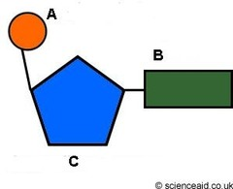____________________

  - ____________________

  - ____________________
- The nitrogen bases:
  - Adenine binds to _____________________

  - Cytosine binds to _____________________

- Erwin Chargaff observed that the amount of adenine always equals the amount of _____________.
- X-Ray diffraction photos taken by Rosalind Franklin suggested that DNA had the shape of a tightly coiled _______________.
- Two scientists that established the structure of DNA: ________________________________

Big Idea 2: Replication of DNA
- Replicate the following segments of DNA:

- AGT CCT CGA GGT ATG b. TCA GAC GTT ACG ATC GAT TAC

_______________________________ _______________________________________

- Which enzyme breaks the hydrogen bonds between the nitrogen bases? ________________________
- Which enzyme unwinds and unzips the DNA during replication? _________________________
- Which enzyme adds nucleotides to the DNA bases? _____________________________
- After replication, you have ___________ double helices. They are/aren’t (circle one) identical to each other. Also, they are/aren’t (circle one) identical to the original parental helix.

Big Idea 3: From Genes to Proteins
- Name 3 ways in which RNA is different from DNA.

- What does RNA stand for? _________________________________
- What nitrogen bases are found in RNA (use full names and letters)?

- Which of the bases you wrote above takes the place of Thymine in DNA? _______________________
- During transcription, ______________ is made.
- The 3 steps of transcription:

- Transcription occurs in the ____________________ of the cell.
- When transcription begins, RNA polymerase binds to a ________________________________.
- Transcribe the following strand of DNA into RNA:
  - GGC TAT GTT AAG CGC GTA

_________________________________

- After transcription, where does the mRNA go? _______________________________
- What is the function of mRNA?

- The three letter nucleotide unit of an mRNA molecule is called a ________________

- Translate these codons into amino acids:

CCA ____________________ GAU __________________________ UGC ______________________________

- Where does translation occur in the cell? _________________________
- What is the workbench of protein synthesis? ______________________
- Amino acids are the monomers of a _____________________
- Describe translation:

- 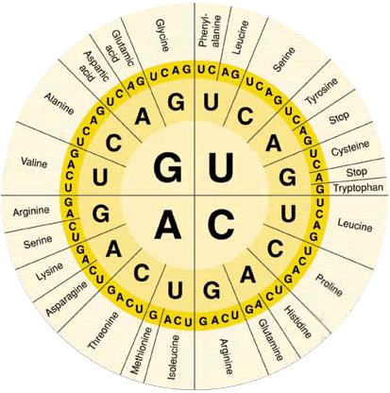What is the end product of transcription and translation?

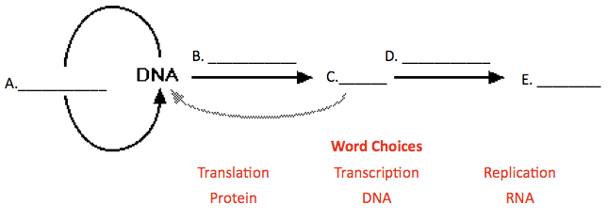

Fill in the blanks: Central Dogma

