**Name: _______________________________**

**Period:______________**

**Directions:** Circle/Highlight/Underline the best answer for each question.

1. Movement across the cell membrane that does not require energy is called  
   [ active / passive ] transport.
2. The difference in the concentration of a substance across a space is called a concentration [ equilibrium / gradient ].
3. If there is a concentration gradient, substances will move from an area of high concentration to an area of [ equal / low ] concentration.
4. The cell membrane is [ selectively permeable / impermeable ]
5. [ Equilibrium / Diffusion ] is the simplest type of passive transport.
6. The diffusion of water through a selectively permeable membrane is called [ osmosis / diffusion ].
7. The direction of water movement across the cell membrane depends on the concentration of free water[ molecules / solutions ].
8. A solution that causes a cell to swell is called a [ hypertonic / hypotonic] solution.
9. The process of taking material into the cell by infolding the cell membrane is called [ endocytosis / exocytosis ]
10. In [ facilitated / molecular ] diffusion, membrane proteins help molecules across the membrane.
11. In diffusion, molecules [ spread out / condense ]
12. The lipid bilayer describes [ a type of transport / the cell membrane ].
13. Facilitated diffusion moves substances down their concentration gradient [ with / without ] using the cell's energy.

**Directions:** Below are animal cell placed in beakers of various concentrations.

1. Draw an arrow to indicate which direction water will move by osmosis.
2. Identify the type of solution the cell has been placed in (hypertonic, hypotonic, isotonic).

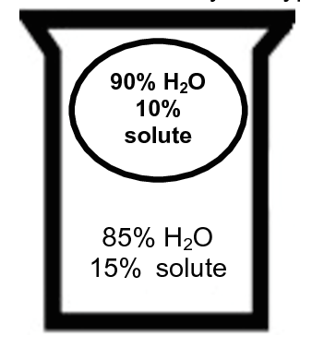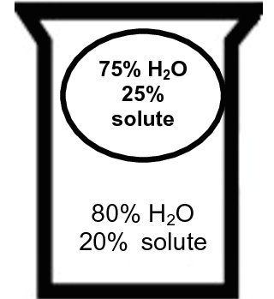a. b.

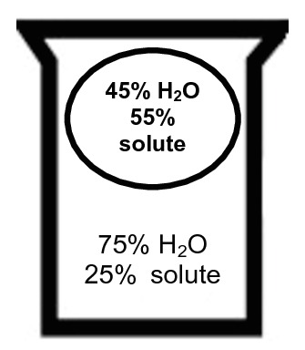Solution: _________________________ Solution: _________________________

c. d. 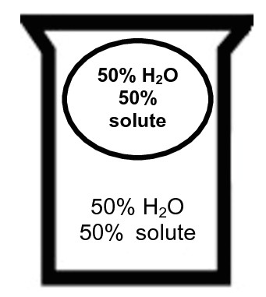

Solution: _________________________ Solution: ________________________

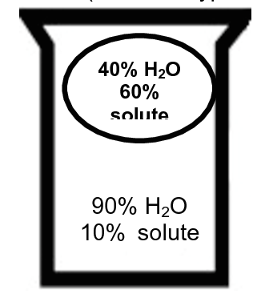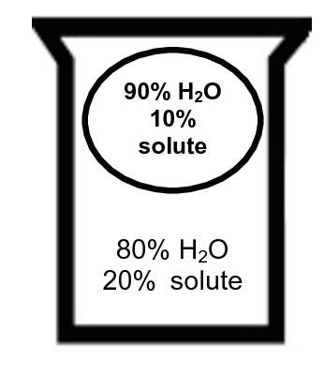e. f.

Solution: _________________________ Solution: _________________________

**Directions:** Name the following organelles

1. _________________________________

* controls the cell
* contains hereditary material (chromosomes, genes, DNA)

2. _________________________________

* fluid/liquid in the cell – jelly – like
* helps transport material around cell

3. _________________________________

* carries out cellular respiration
* gives cell energy (“powerhouse of the cell”).

4. _________________________________

* reads builds proteins from amino acids.

5. _________________________________

* stores food, water and waste
* food vacuoles may digest large molecules
* waste vacuoles may excrete waste out the cell membrane

6. _________________________________

* carries out photosynthesis
* only found in plant and algae cells

7. _________________________________

* gives **plant** cell shape, structure and protection
* NEVER found in animal cells

8. ________________________________

* separates cell interior from environment
* controls what enters and leaves the cell
* What does the cell theory tell us about cells?
* How are plant cells and animals similar? How are they different?
* How are prokaryotic and eukaryotic cells similar? How are they different?

Label the organelles above:

A ______________

B_______________

C_______________

D ____Centriole___

E_______________

F_______________